CURRICULUM VITAE

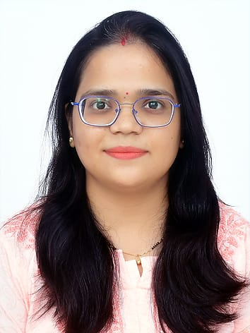
Renuka Dohare
Email: renuka.dohare@gmail.com
Contact No: +91 9026734247, 7736172857
Designation – Relationship Manager (R.M)
Experience- 5 Years

CAREER OBJECTIVE: Work in a dynamic environment that provides me a wide spectrum of experience and exposure. To serve the organization with positive attitude and efficiency with lots of hard work.

EDUCATIONAL QUALIFICATION:
- M.B.A in 2020 from INTEGRAL University, LUCKNOW (U.P.)
- B.Sc in 2014 from Kanpur University, KANPUR
- Class XII in 2010 from U.P. Board UTTAR PRADESH
- Class X in 2008 from CBSE Board

PROFESSIONAL ACHIEVEMENT:
- CANARA HSBC OBC 2021, achieved 200 percent of expected target
- CANARA HSBC OBC 2021Awarded as the top performer for the halfly target
- ICICI PRUDENTIAL 2018,achieved 150 percent of expected target
ICICI PRUDENTIAL 2018. Awarded as the top performer for the first quarter of 2018 in “BANCA NIGHTS”.

AWARDS/RECOGNITION:
'PAN India award' in July 2021 for achieving the July 2021 target of 820 per cent

EXTRA CURRICULAR:
Active participation in promotional activities conducted by ICICI Bank for saving/current account. Active supervision and co-ordination in seminars and other activities.
WORK EXPERIENCE:
- Currently working in CANARA HSBC OBC (SEP 2020- NOV 2021)
Taken promotion within a 6 months by competed 200% target of expected target.
- 1 year Work Experience in TATA AIA (2019-2020) Designation : Senior Financial Services Consultant
- 1 year Work Experience in ICICI PRUDENTIAL (2017-2018)
Designation : Financial Services Consultant
Role & Responsibility:
Responsibilities:
- Client Engagement:
  - Act as the primary point of contact for assigned clients.
  - Build and maintain strong, long-lasting client relationships.
- Needs Assessment:
  - Understand client needs and objectives to provide tailored solutions.
  - Conduct regular meetings to assess client satisfaction and gather feedback.
- Product Knowledge:
  - Stay updated on company products and services to effectively recommend solutions.
  - Educate clients about new offerings that may benefit them.
- Account Management:
  - Oversee client accounts, ensuring they are managed effectively.
  - Monitor account performance and resolve any issues that arise.
- Sales and Upselling:
  - Identify opportunities for upselling or cross-selling additional products/services.
  - Collaborate with sales teams to drive revenue growth.
- Reporting and Analysis:
  - Prepare reports on account status, client engagement, and market trends.
  - Analyze data to identify areas for improvement or opportunities for growth.
- Conflict Resolution:
  - Address any client complaints or concerns promptly and professionally.
  - Mediate disputes and work towards satisfactory resolutions.
- Collaboration:
  - Work closely with other departments (e.g., marketing, product development) to align client needs with company offerings.
  - Facilitate communication between clients and internal teams.
- Networking:
  - Attend industry events and conferences to build professional relationships and expand the client base.
  - Leverage professional networks to benefit clients.
- Continuous Improvement:
  - Stay informed about industry trends and competitor activities.
  - Seek feedback to enhance service delivery and client satisfaction.
COMPUTER PROFIENCY:
- MS Office
- Internet with E-mail Management
Other: Printing, Scanning, Backup/Restore etc.
PERSONAL DETAILS:
- Gender: Female
- Date of Birth: 10th FEB 1992
- Nationality: Indian
- Marital Status: Married
- Father’s Name: Sushil Babu Dohare
- Mother’s Name: Rekha Dohare
- Languages known: English, Hindi
Present address: 208 3rd main KEB LAYOUT Sanjay Nagar Banglore Karnatka

DECLARATION: I hereby declare that the information furnished above is true to the best of my knowledge.
Renuka Dohare
Date: 20 Sep 2024

